**First quick filter: (After sign up)**

I am looking to Foster | Adopt | (ok to select both)

Enter city, state, or zip

Find dog | Find a cat | Find other pets >

**Detailed filter**

Select Species

Dog/ Cat/ others

Size:

If choose dog: S ( 0-25lbs)/ M ( 25-60lbs)/ L(61-100lbs) Extra large ( 101 lbs or more)

If choose cat: S(0-6 ibs)/ M(7-11ibs)/ L(12-16lbs)/ XL (17 lbs or more)

If choose others: S/ M/ L/ XL

Age:

baby / Young/ Adult/ Senior

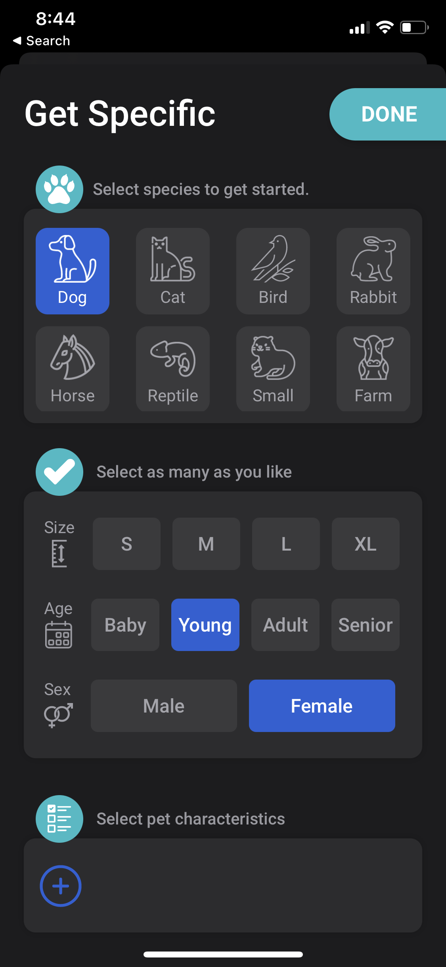

Gender:

Female/ Male

Good with:

Kids/ dog/ cats

Coat length:

short/ medium/ long

Sample layout for detailed filter: